SCHEDULE OF LECTURES
ON DRUG TECHNOLOGY IN PHARMACY
for the 3-rd year students of the Pharmaceutical Faculty
5th semester
№ | Topic | Dura-tion
1. | Pharmaceutical technology as a science and educational discipline. Biopharmaceutical aspects of pharmaceutical technology. Drugs preparation in pharmacy according to the requiments of good pharmacy practice (GPP) | 2
2. | Dosage forms, their classification. Powders as a dosage form. General rules of technology of powders | 2
3. | Powders. Technology of different types of powders – powders with poison and strong active substances, dyeing and crystalline substances, extracts and liquids | 2
4. | Liquid preparations. Solvents for liquid preparations. Purified Water as a main solvent in drug technology.  Technology of liquid preparations by weight in volume method | 2
5. | Concentrated solutions. Technology of liquid preparations in weight in volume method by dissolving dry substances and with using concentrated solutions | 2
6. | Standart Pharmacopoeia liquids. Preparing of dilutions | 2
7. | Non-aqueous solutions, peculiarity of technology. Drops. | 2
8. | Solutions of macromolecular substances and colloids, properties and peculiarity of technology | 2
9. | Heterogeneous dosage forms. Suspensions as formulated preparations. Properties of suspentions as dispersive systems. Methods of preparing and stabilisation of suspension | 2
10. | Emulsions as formulated preparations. Properties of emulsions and factors affecting stability of emulsions | 2
11. | Water extracts from plant material. Technology of liquid preparations containing water extracts. Using of extracts in technology of liquid preparations | 2
Total |  | 22

SCHEDULE OF PRACTICAL CLASSES
ON DRUG TECHNOLOGY IN PHARMACY
for the 3-rd year students of the Pharmaceutical Faculty
5th semester
№ | Topic |  | Duration
1. | Main terms in drug technology. Drug legislation and regulations |  | 4
2. | Dosage and measures in pharmacy practice |  | 4
3. | Technology of simple and compound powders with medicinal substances that difference phisico-chemical properties and amount |  | 4
4. | Technology of compound powders with poison and strong active substances. Triturations |  | 4
5. | Technology of compound powders with dyeing substances |  | 4
6. | Technology of compound powders with crystalline substances |  | 4
7. | Technology of compound powders with extracts and liquids  Control of content module 1 |  | 4
8 | Technology of liquid preparations by weight in volume method |  | 4
9. | Peculiar cases of aqueous solutions technology
10. | Technology of concentrated solutions |  | 4
11. | Technology of liquid preparations in weight in volume concentration with using concentrated solutions |  | 4
12. | Technology of aqueous solutions of standard Pharmacopoeia liquids |  | 4
13. | Technology of non-aqueous solutions. Dilutions of Ethanol |  | 4
14. | Technology of drops for oral administration and topical application |  | 4
15. | Technology of macromolecular substances solutions and colloids. |  | 4
16. | Technology of suspensions |  | 4
17. | Technology of emulsions |  | 4
18. | Technology of water extracts from medicimal plant materials |  | 4
19. | Technology of water extracts from plant materials containg alkaloids and cardiac glycosides
20. | Technology of of liquid preparations with using extracts
21. | Final module control |  | 4
TOTAL |  | 84

QUESTIONS FOR SELF-TRAINING
ON DRUG TECHNOLOGY IN THE PHARMACY
for the 3-rd year students of the Pharmaceutical Faculty
5th semester

№ | Topic | Duration
1. | Preparation to practical classes – theoretical preparation and working of the recommended prescriptions | 40
2. | Self-training of themes which are not included in the plan of  practical classes:
2.1 | Prescription, its value. Structure of prescription | 1
2.2 | Structure of scales, care of scales and sets of standart weights. Devices and apparatus for dosage. | 1
2.3 | Requirements to the sanitary state and pharmaceutical order in a pharmacy | 1
2.4 | Requirement to the storage conditions in the pharmacies for different groups of preparations | 1
2.5 | Packaging material in technology of medicinal preparations and its influence on quality of dosage forms. | 1
2.6 | Cleaning of water before distillation. Aquadistilators, peculiarity of construction. Demineralization of water | 1
2.7 | Peculiarity of technology of some liquid preparations according to the author’s compositions | 1
2.8 | Requirements of Pharmacopoeia to nasal and ear preparations | 1
3. | Preparation to the control of content modules | 4
4. | Preparation to the final module control | 4
5. | Individual work - preparation of review of scientific literature or  research one of the themes
Total 56

SCHEDULE OF LECTURES
ON DRUG TECHNOLOGY IN PHARMACY
for the 3-rd year students of the Pharmaceutical Faculty
6th semester

№ | Topic | Duration
1. | Topical semi-solid preparations. Classification and requirements of Pharmacopoeia. General rules of topical semi-solid preparations’ technology. | 2
2. | Technology of semi-solid preparations according to the type of dispersive system. | 2
3. | Rectal and vaginal dosage forms. Requirements Pharmacopoeia, technology and quality control. | 2
4. | Sterile preparations. Aseptic conditions. Parenteral preparations. | 2
5. | Sterile preparations. Technology of parenteral preparations in pharmacy, sterilization and quality control. | 2
6. | Stability of parenteral preparations. Factors affecting stability of parenteral preparations/ Methods of stabilisation. | 2
7. | Intravenous infusions. Calculation of isotonicity and isoosmoticity of infusions. | 2
8. | Ophthalmic preparations. Preparations with antibiotics. | 2
9 | Homeopathy. General principles of homeopathic preparations’ technology. Veterinary pharmacy. Technology of veterinary preparations/ | 2
Total 18

SCHEDULE OF PRACTICAL CLASSES
ON DRUG TECHNOLOGY IN PHARMACY
for the 3-rd year students of the Pharmaceutical Faculty
6th semester

№ | Topic | Duration
1. | Technology of single-phase ointments. Gels. | 4
2. | Technology of double-phase ointments. Pastes. | 4
3. | Technology of multi-phase semi-solid preparations. Creams. | 4
4. | Technology of liniments according to the type of dispersive system. | 4
5. | Technology of suppositories by rolling method. | 4
6. | Technology of moulded suppositories and pessaries. | 4
7. | Biopharmaceutical aspects of bases selection for technology of topical semi-solid preparations, suppositories and pessaries. Control of content module 3. | 4
8. | Organisation of aseptic conditions in pharmacy. Technology of solutions for injections without stabilization. | 4
9. | Technology of solutions for injections with acid and alkali stabilization. | 4
10. | Technology of solutions for injections with antioxidant stabilization. | 4
11. | Technology of isotonic solutions for injections and infusions. | 4
12. | Technology of plasma substitute liquids | 4
13. | Technology of eye drops and eye lotions. | 4
14. | Technology of eye semi-solid preparations. | 4
15. | Technology of preparations for newborns. | 4
16. | Technology of dosage forms containing antibiotics. | 4
17. | Difficult prescriptions. Drug interactions in dosage forms. | 4
18. | Nomenclature of moden extemporaneous preparations. Supporting of course projects. Control of content module 4. | 4
19. | Final module control | 4
Total 76

QUESTIONS FOR SELF-TRAINING
ON DRUG TECHNOLOGY IN THE PHARMACY
for the 3-rd year students of the Pharmaceutical Faculty
6th semester

1. | Topic | Duration
1. | Preparation to practical classes – theoretical preparation and working of the recommended prescriptions | 36
Self-training of themes which are not included into the plan of
practical classes:
2 | Characteristic of bases for topical semi-solid preparations, their biopharmaceutical investigations. | 2
3. | Characteristic of emulgators. Calculation of the amount of surface active agents needed for preparing ointments and creams. | 2
4. | Semi-solid preparations for protection of skin and skin care. | 1
5. | Characteristic of bases for suppositories and pessaries, their biopharmaceutical investigations. Calculations of bases needed for preparing suppositories by different methods. | 2
6. | Technology of suppositories by compressing method. | 1
7. | Sanitary-hygienic requirements to the preparation of sterile dosage forms in pharmacy. | 2
8. | Aquadislillators, their types and principles of work.Non-aqueous solvent for parenteral preparations. | 2
9. | Types of containers for parenteral preparation, requirements to them. | 2
10. | Materials and apparatus for filtration and packaging of parenteral preparations. Control of parenteral preparations on mechanical comtamination | 2
11. | Apparatus for sterilization of medicinal preparations and other objects in pharmacy. | 1
12. | Methods of introduction of parenteral preparations. Types of injections. Rate of therapeutical effect according to the method of administration. | 1
13. | Methods of control of parenteral preparations: tests on sterility, pyrogens, bacterial endotoxins and toxicy properties. | 2
14. | Formulated preparations for the children of different age. | 2
15. | Phisical, chemical and pharmacological drug interactions in dosage forms. | 2
16. | Preparation to the control of content modules | 4
17. | Preparation to the final module control | 4
Total 68

CALENDAR AND THEMATIC SCHEDULE OF LECTURES
on physical and colloidal chemistry for the 3rd year students of pharmaceutical faculty
during the autumn term of 2012– 2013 academic year
Group 7 T o p i c s a n d c o n t e n t s o f l e c t u r e s
Module 2 «Colloidal chemistry»
Number
Date of hours
06.09 Surface phenomena and their significance. Sorption processes and
their theoretical basis. Adsorbtion of a liquid-gas interface. Surfactants
2
20.09 Adsorbtion on the solid-gas and solid-solution interfaces.
Adsorbents, their classification and application
2
04.10 The adsorbtion of electrolytes. Ions-exchange adsorbtion.
Chromatography methods and their classification
2
18.10 Dispersed systems, their classification and preparation methods 2
01.11 Dispersed systems micelles structure. The structure of the double
electric layer. Electro-kinetical phenomena
2
15.11 Molecular-kinetical and optical properties of the dispersed systems.
The stability of the dispersed systems and their coagulation. The
methods of sols purification
2
29.11 Aerosols and powders. Suspensions 2
13.12 Emulsions. Colloidal surfactants 2
27.12 The basic concept of polymers. Preparation and properties of highlymolecular
compounds solutions
2
10.01 Viscosity of polymers solutions. Polyelectrolytes. Properties of gels 2
Totally: 20
Confirmed by the Department session
Protocol No. 2 dated «31» August 2012
___________ Associate professor V.Ogurtsov
CALENDAR AND THEMATIC SCHEDULE
of practice and laboratory studies on physical and colloidal chemistry
for the 3rd year students of pharmaceutical faculty
during the autumn term of 2012– 2013 academic year
Group 7
The topics
Number
Date of hours
Thematic module 4. Physical chemistry of surface and sorption phenomena.
Chromatography
03.09 Surface phenomena and their significance. Sorption processes and their
theoretical basis
2
10.09 Adsorbtion of a liquid-gas interface. Surfactants. The surface tension of
solutions determination
2
17.09 Adsorbtion on the solid-gas and solid-solution interfaces 2
24.09 Adsorbents, their classification and application 2
01.10 The adsorbtion of electrolytes. Ions-exchange adsorbtion 2
08.10 Chromatographic methods and their classification 2
15.10 Chromatography application 2
Thematic module 5. Dispersed systems and their properties
22.10 Dispersed systems, their classification and preparation methods 2
29.10 Dispersed systems micelles structure. The structure of the double electric
layer
2
05.11 Electro-kinetical properties of lyophobic sols 2
12.11 Molecular-kinetical and optical properties of the dispersed systems 2
19.11 The stability of the dispersed systems and their coagulation. The methods
of sols purification
2
26.11 Suspensions. Aerosols and powders 2
03.12 Emulsions 2
10.12 Colloidal surfactants 2
Thematic module 6. Physical chemistry of polymers
17.12 The basic concept of polymers 2
24.12 Preparation and properties of highly-molecular compounds solutions 2
14.01 Viscosity of polymers solutions. Polyelectrolytes 2
21.01 Properties of gels 2
24.01 The final control of the acquirement the Module 2 “Colloidal chemistry” 2

THEMATIC PLAN

of Out-classes works of “Pharmaceutical chemistry”

for the 3-rd Year students of the Faculty of Pharmacy

(autumn semester of 2012/2013 educational year)
№ п/п | Topic | Hours | Date
1 | State Pharmacopoeia of Ukraine and its structure. Parameters which are used for the standardization of drugs (description, solubility, identification, testing for purity, quantitative determination). Reactions of cations identification by SPU. Identification of: aluminum, antimony, bismuth, lead, silver. | 3 | September
2 | Chemical methods. Reactions identification anions by DFU. Identification of: silicates, sulfites, acetates, lactates, citrates. | 3 | September
3 | Tests for purity: definition of transparency, color and reaction of solutions of drugs. Production turbidity standards (reagents, dilution, initial suspension, the bulk suspension). Production of color standards (yellow, red, blue). Reagents, solutions, methods I, and the method II by SPU. Relationship between reaction of solution, approximate pH and color indicators. Working with Table alkaline, neutral, acidic and strongly acidic reaction solutions for SPU. | 3 | September
4 | Tests for purity: impurity, their types and methods of determination. Reference solutions. Tests for limiting the amount of inorganic impurities in drugs. Chromatographic methods for detection of impurities. Detection of free formaldehyde, antioxidants and sterols in fatty oils. | 3 | September
5 | Analysis of purified water, high-cleared water and water for injection. Methods of preparation and purification of purified water, water high-cleared, water for injection in pharmacies and industry. Requirements for the parameters of conductivity and microbiological purity for purified water, high-cleared water and water for injection. | 3 | October
6 | Inorganic drugs with halogen atoms in the molecules. Bactericidal activity of chlorine. Extraction of iodine from seaweed and drilling fluid. Purification, properties, application of iodine. Yodinola and yodovidon. Chemical properties, quality requirements. Pharmacological action. | 3 | October
7 | Inorganic medicinal substance with oxygen atoms in the molecules.  Oxygen as a drug. Terms of storing and dispensing. | 3 | October
8 | Inorganic drugs with sulfur atoms in the molecules. Sodium sulfate, method of obtaining, properties, applications, storage. Sulfur cleared, properties, pharmacological effect relative to the sulfur precipitated. | 3 | October
9 | Inorganic medicinal substances with atoms of nitrogen, bismuth and carbon in the molecules. Activated charcoal. Comparison of requirements for quality Ph X, SPU, additions II and III. Use in medicine. Nitrogen (I) oxide. Preparation, analysis, storage and use. Pentabismol. Historical aspects and conditions of synthesis. The method of obtaining, analysis features, use in medicine. Sodium carbonate. Properties and methods of analysis. Methods for distinguish carbonates from hydrocarbonates. | 3 | October
10 | Inorganic drugs with boron and aluminum atoms in molecules. Aluminum hydroxide. Properties and methods of analysis, use in medical practice. | 3 | November
11 | Inorganic drugs with magnesium and calcium atoms in molecules. Physiological antagonism between calcium and magnesium. Violation of imbalance in the body and its effects. Antidote. | 3 | November
12 | Analysis of barium sulfate for X-rays. Toxicity of barium salts. Relevance determination of impurities (soluble salts of barium) in drugs. | 3 | November
13 | Inorganic drugs with zinc and mercury atoms in molecules. Mercury oxide yellow. Properties, analysis, use in medicine. | 3 | November
14 | Inorganic medicinal substances with atoms of copper, silver, iron and manganese in the molecules. Colloidal silver preparations: collargolum, protargol. Extraction methods of analysis, use in medicine. | 4 | December
15 | Physical and physico-chemical methods of analysis of organic drugs (determination of relative density, melting point, boiling point, IR, UV, NMR spectroscopy, chromatographic methods). Determination of relative density using densitometer with oscillating transformer bySPU (add. III). Determination of melting point by temperature instrumental method according SPU (add. III). The method of thin layer chromatography, equipment, techniques, visual assessment, quantitative measurement (SPU, add. III) | 3 | December
16 | Determination of the refractive index and concentration of solutions of organic drugs by refractometry. Determination of optical rotation and concentration of solutions of organic drugs using polarimetric method. | 3 | December
17 | Chemical methods. The elemental analysis. Identification reactions of drugs for analytical and functional groups. Quantitative determination of nitrogen after mineralization with sulfuric acid according SPU. | 3 | January
18 | Chemical methods for the quantitative determination of drugs. Reactions identification of alkaloids, barbiturates, xanthine by SPU. Quantitative determination of aluminum by SPU. | 3 | January
19 | Medicinal substances with aliphatic structures: halogen aliphatic hydrocarbons, alcohols and aldehydes from aliphatic series. Chloral hydrate. Methods of analysis, especially storage. Ethambutol. Properties, analysis, use. | 3 | January
Разом |  | 58

CALENDAR AND THEMATIC PLAN

of laboratory works of “Pharmaceutical chemistry”

for the 3-rd Year students of the Faculty of Pharmacy

(autumn semester of 2012/2013 educational year)

№ п/п | Topic | Hours | Group / Date
 |  |  | 1, 2, 5, 6 | 3-4 | 7
1 | 2 | 3 | 4 | 5 | 6
Module 1. Inorganic Drugs
1 | State Pharmacopoeia of Ukraine and its structure. Parameters which are used for the standardization of drugs (description, solubility, identification, testing for purity, quantitative determination). Reactions of cations identification by SPU. | 3 | 03.09 | 04.09 | 06.09
2 | Chemical methods. Reactions of anions identification by SPU. | 3 | 10.09 | 11.09 | 13.09
3 | Tests for purity: definition of transparency, color and reaction of solutions of drugs. | 3 | 17.09 | 18.09 | 20.09
4 | Tests for purity: impurity, their types and methods of determination. Reference solutions. Tests for limiting the amount of inorganic impurities in drugs. | 3 | 24.09 | 25.09 | 27.09
5 | Analysis of purified water, high-cleared water and water for injection. | 3 | 01.10 | 02.10 | 04.10
6 | Inorganic drugs with halogen atoms in the molecules. | 3 | 08.10 | 09.10 | 11.10
7 | Inorganic medicinal substance with oxygen atoms in the molecules. | 3 | 15.10 | 16.10 | 18.10
8 | Inorganic drugs with sulfur atoms in the molecules. | 3 | 22.10 | 23.10 | 25.10
9 | Inorganic medicinal substances with atoms of nitrogen, bismuth and carbon in the molecules. | 3 | 29.10 | 30.10 | 01.11
10 | Inorganic drugs with boron and aluminum atoms in the molecules. | 3 | 05.11 | 06.11 | 08.11
11 | Inorganic drugs with magnesium and calcium atoms in the molecules. | 3 | 12.11 | 13.11 | 15.11
12 | Analysis of barium sulfate for X-rays. | 3 | 19.11 | 20.11 | 22.11
13 | Inorganic drugs with zinc and mercury atoms in the molecules. | 3 | 26.11 | 27.11 | 29.11
14 | Inorganic medicinal substances with atoms of copper, silver, iron and manganese in the molecules | 3 | 03.12 | 04.12 | 06.12
15 | Module 1 | 3 | 10.12 | 11.12 | 13.12
Module 2. Organic drugs with aliphatic and alicyclic structure
16 | Physical and physico-chemical methods of analysis of organic drugs (determination of relative density, melting point, boiling point, IR, UV, NMR spectroscopy, chromatographic methods) | 3 | 17.12 | 18.12 | 20.12
17 | Determination of the refractive index and concentration of solutions of organic drugs by refractometry. Determination of optical rotation and concentration of solutions of organic drugs using polarimetric method | 3 | 24.12 | 25.12 | 27.12
18 | Chemical methods. The elemental analysis. Reactions of drugs identification for analytical and functional groups. | 3 | 26.12 | 26.12 | 10.01
19 | Reactions of drugs identification for analytical and functional groups (continuation). Chemical methods for the quantitative determination of drugs by SPU. | 3 | 14.01 | 15.01 | 17.01
20 | Analysis of drugs, halogen aliphatic hydrocarbons, alcohols and aldehydes with aliphatic structure. | 3 | 21.01 | 22.01 | 24.01
21 | Analysis of drugs from the group of vitamins with aliphatic structures | 3 | 23.01 | 23.01 | 24.01
Всього |  | 63

Calendar and thematic plan
of lectures of “Pharmaceutical chemistry ” for the in the 3-d Year students
of the Faculty of Pharmacy
(autumn semester of 2012/2013 educational year)

№ п/п | Тема лекції | Група | Дата
1 | 2 | 3 | 4
1 | Subject and objectives of pharmaceutical chemistry, history of development. State Pharmacopoeia of Ukraine and its structure. Parameters which are used for the standardization of drugs (description, solubility, identification, testing for purity, quantitative determination). Reactions of ions identification by SPU. | 1-6  7 | 05.09  13.09
2 | Tests for purity: definition of transparency, color and reaction of the drugs. Tests for purity: impurity, their types and methods of determination. Reference solutions. Tests for limiting the amount of inorganic impurities in drugs. | 1-6  7 | 19.09  27.09
3 | Analysis of purified water, water high-cleared and water for injection. Inorganic drugs with halogen atoms in the molecules. | 1-6  7 | 03.10  11.10
4 | Inorganic medicinal substances with atoms of oxygen and sulfur in the molecules. Inorganic medicinal substances with atoms of nitrogen, bismuth and carbon in molecules. | 1-6  7 | 17.10  25.10
5 | Inorganic drugs with boron and aluminum atoms in molecules. Inorganic drugs with magnesium and calcium atoms in molecules. Analysis of barium sulfate for X-rays. | 1-6  7 | 31.10  08.11
6 | Inorganic drugs with zinc and mercury atoms in molecules. Inorganic medicinal substances with atoms of copper, silver, iron and manganese in the molecules. | 1-6  7 | 14.11  22.11
7 | Physical and physico-chemical methods of analysis of organic drugs. Determination of the refractive index and concentration of solutions of organic drugs by refractometry. Determination of optical rotation and concentration of solutions of organic drugs using polarimetric method. | 1-6  7 | 28.11  06.12
8 | Chemical methods. The elemental analysis. Reactions of analytical and functional groups identification of drugs. Chemical methods for the quantitative determination of drugs. | 1-6  7 | 12.12  20.12

TIMETABLE OF LECTURES
OF MICROBIOLOGY FOR
PHARMACY FACULTY
(autumn semester 2012-2013)

N | TOPIC | DATE
1. | Pathogenic cocci. | 3.09
2. | Pathogenic enterobacteria. | 17.09
3. | Causative agents of respiratory bacterial infection (diphtheria, pertussis, tuberculosis). | 1.10
4. | Pathogenic anaerobes. | 15.10
5. | Phytopathogenic microorganisms. | 29.10

TIMETABLE OF THE PRACTICAL
CLASES OF MICROBIOLOGY FOR
PHARMACY FACULTY
(autumn semester 2012-2013)
(30 hours)
N | T O P I C | Group 7
1 | 2 | 3
1. | Pathogenic cocci. Microbiological diagnosis. Drugs for treatment, prevention and diagnosis. | 10.09
2. | Causative agents of intestinal bacterial infections. Escherichia, Salmonella,Shigella. Microbiological diagnosis. Drugs for treatment, prevention and diagnosis. | 24.09
3. | Causative agents of cholera, plague. Microbiological diagnosis. Drugs for treatment, prevention and diagnosis. | 8.10
4. | Causative agents of diphtheria , pertussis, tuberculosis. Microbiological diagnosis. Drugs for treatment, prevention and diagnosis. | 22.10
5. | Pathogenic anaerobes. Microbiological diagnosis. Drugs for treatment, prevention and diagnosis. | 5.11
6. | Pathogenic spirochetes. Microbiological diagnosis. Drugs for treatment, prevention and diagnosis. | 12.11
7. | Clinical microbiology. | 19.11
8. | Microflora of environment (water, air,soil). Microflora of the human body. | 26.11
9. | Microflora of pharmacy, drug plants and medical preparations. | 3.12
10. | MODULE 2. | 10.12

TIMETABLE OF LECTURES
OF MICROBIOLOGY FOR
PHARMACY FACULTY
(autumn semester 2012-2013)

N | TOPIC | DATE
1. | Pathogenic cocci. | 3.09
2. | Pathogenic enterobacteria. | 17.09
3. | Causative agents of respiratory bacterial infection (diphtheria, pertussis, tuberculosis). | 1.10
4. | Pathogenic anaerobes. | 15.10
5. | Phytopathogenic microorganisms. | 29.10

TIMETABLE OF THE PRACTICAL
CLASES OF MICROBIOLOGY FOR
PHARMACY FACULTY
(autumn semester 2012-2013)
(30 hours)
N | T O P I C | Group 7
1 | 2 | 3
1. | Pathogenic cocci. Microbiological diagnosis. Drugs for treatment, prevention and diagnosis. | 10.09
2. | Causative agents of intestinal bacterial infections. Escherichia, Salmonella,Shigella. Microbiological diagnosis. Drugs for treatment, prevention and diagnosis. | 24.09
3. | Causative agents of cholera, plague. Microbiological diagnosis. Drugs for treatment, prevention and diagnosis. | 8.10
4. | Causative agents of diphtheria , pertussis, tuberculosis. Microbiological diagnosis. Drugs for treatment, prevention and diagnosis. | 22.10
5. | Pathogenic anaerobes. Microbiological diagnosis. Drugs for treatment, prevention and diagnosis. | 5.11
6. | Pathogenic spirochetes. Microbiological diagnosis. Drugs for treatment, prevention and diagnosis. | 12.11
7. | Clinical microbiology. | 19.11
8. | Microflora of environment (water, air,soil). Microflora of the human body. | 26.11
9. | Microflora of pharmacy, drug plants and medical preparations. | 3.12
10. | MODULE 2. | 10.12

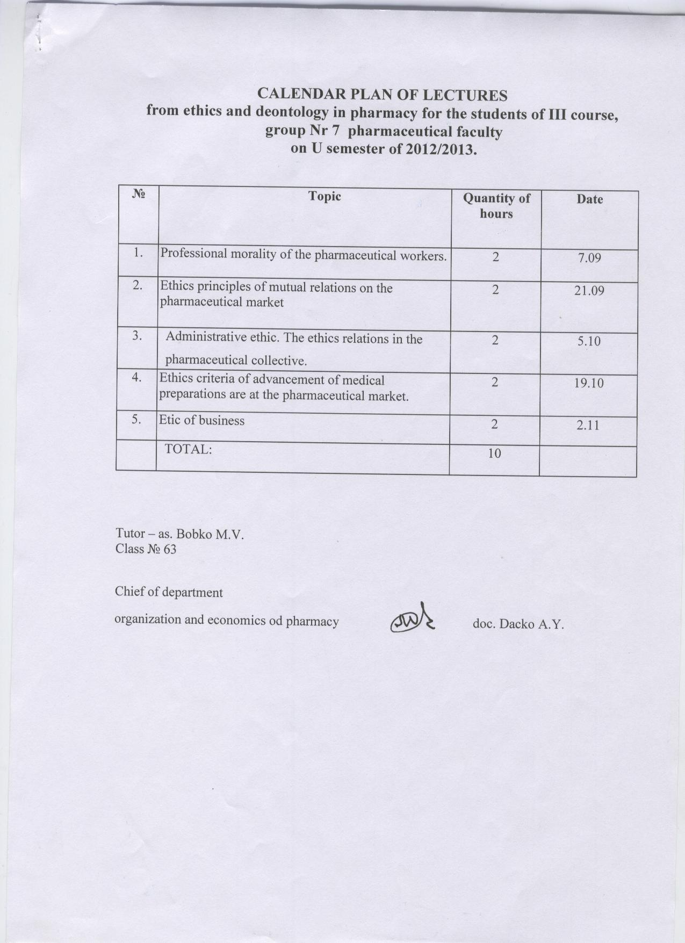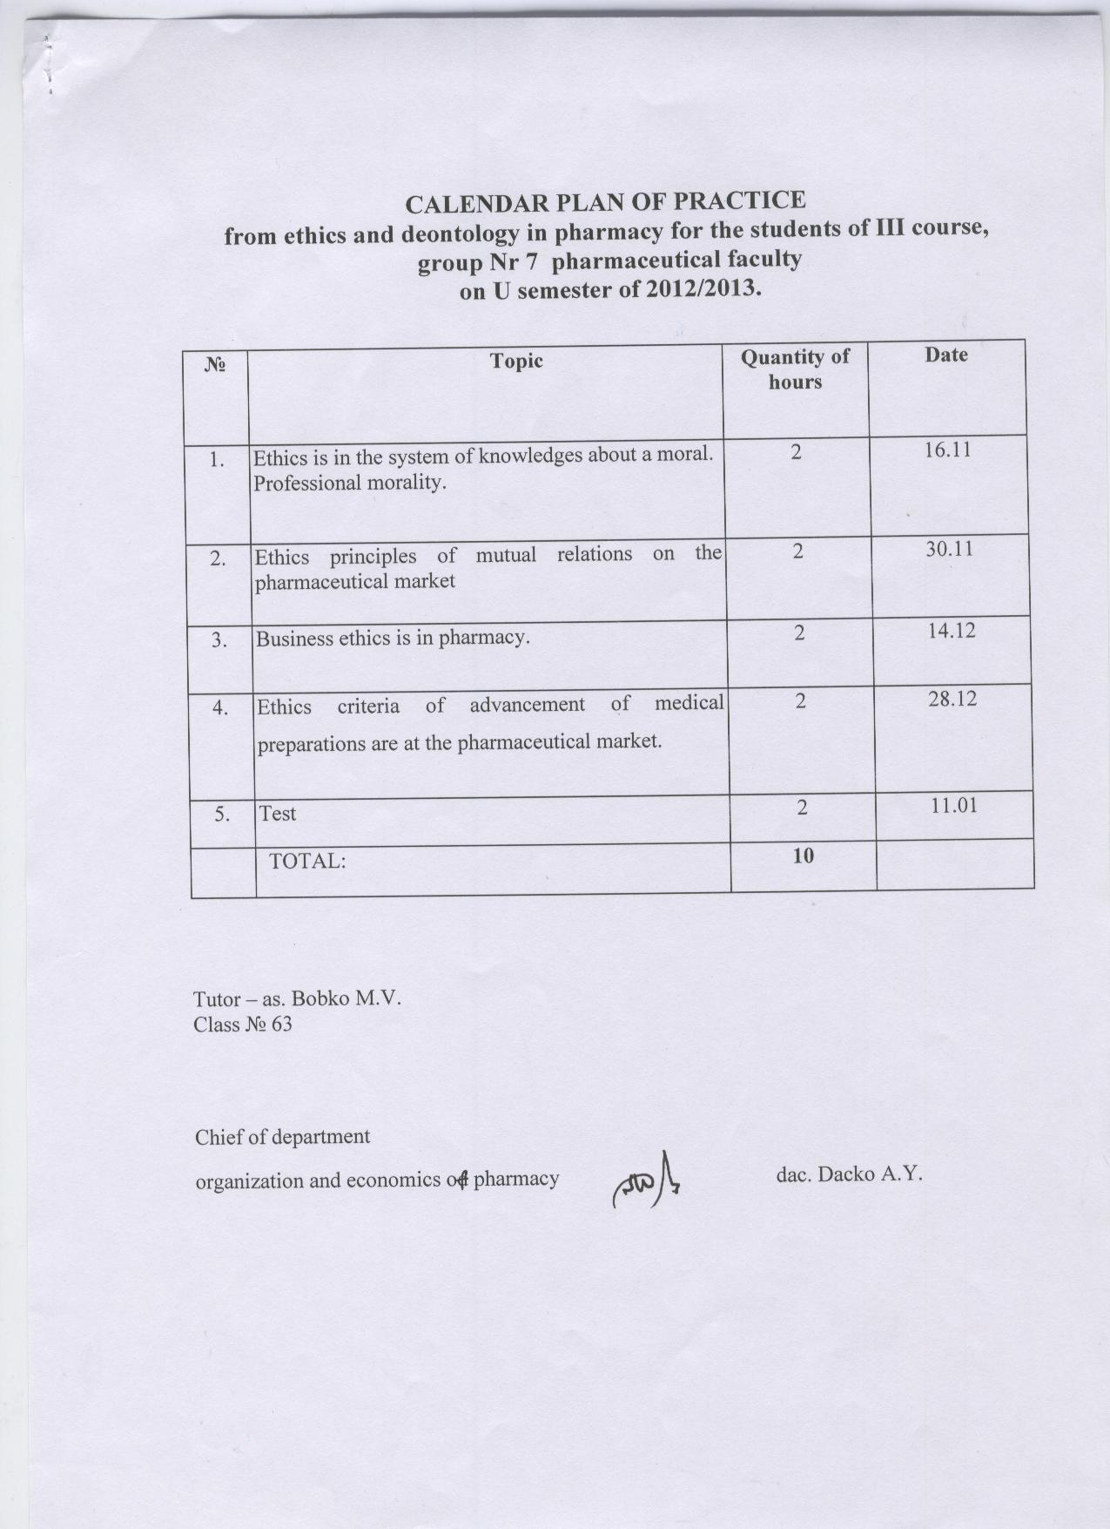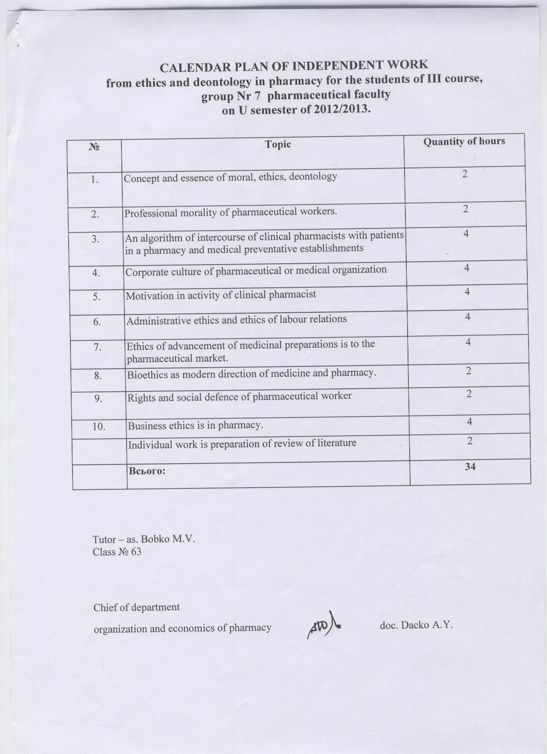
Thematic plan of the lectures
on Pharmacognosy
for the students of ІІІ course of pharmaceutical faculty
for autumn semester 2012-2013 study years

№№ | Themes of lectures | Hours
1. | Pharmacognosy as the science and discipline, its tasks and objects for investigation. Major terms of pharmacognosy, nomenclature of medicinal plants and medicinal plant materials (MPM). Chemical content of medicinal plants, their classification. Methods of pharmacognostic analysis. | 2
2. | System of MPM standardization in Ukraine, Order of elaboration, compliance and approval of the analytic and normative documents on medicinal plant materials. Sampling of material. Determination of identity and quality of medicinal plant materials according to Standard Technical documents | 2
3. | Polysaccharides. Classification, physical and chemical properties. Chemical reactions for identification and quantitative determination, uses in medicine. Plants and MPM containing polysaccharides. | 2
4. | Vitamins. Distribution in plant kingdom, classification. Influence of vegetation phases and environmental conditions on the accumulation of vitamins in plants. Chemical reactions for identification and quantitative determination. Uses in medicine. Plants and medicinal plant materials containing vitamins. | 2
5. | Isoprenoids, volatile oils. Classification, distribution in plant kingdom and localization in plant materials. Influence of ontogenetic factors and environmental conditions on the accumulation in plants. Biosynthesis of terpenoids. | 2
6. | Physical and chemical properties of volatile oils. The methods of obtaining of volatile oil from medicinal plant materials. Methods of quantitative determination of volatile oils and analysis of purity and adulterants in volatile oils. Plants and medicinal plant materials containing terpenoids and volatile oils. | 2
7. | Iridoids as a group of biological active substance, properties, sources and uses in medicine. | 2
8. | Lipids and fixed oils. Classification, physical and chemical properties of fixed oils, the methods of obtaining. Methods of quantitative determination of fixed oils and analysis of purity (physical and chemical indices). Plants and medicinal plant materials containing fixed oils, medicinal uses. | 2
9. | Glycosides, nomenclature and classification, general characters. Methods of analyses. Glucosinolate compounds and cyanogenetic glycosides, their properties. Plants and medicinal plant materials containing glucosinolate compounds and cyanogenetic glycosides. Uses in medicine. | 2
10. | Saponins. Peculiarities of classification. Physical and chemical properties. Methods of analyses. Pharmacological action. Plants and medicinal plant materials containing saponins. Uses in medicine. | 2
11. | Cardiosteroids. Classification, physical and chemical properties. Methods of extraction, detection and quantitative determination. Peculiarities of standardization. Plants and medicinal plant materials containing cardiosteroids. Uses in medicine. | 2
 | Total: | 22
Thematic plan of laboratory works
on Pharmacognosy
for the students of ІІІ course of pharmaceutical faculty
for autumn semester 2012-2013 study years

№№ | Themes of laboratory works | Hours
1. | Unit 1. General part of Pharmacognosy. Medicinal plants and medicinal plant materials (MPM) containing polysaccharides, vitamins, glucosinolate compounds, cyanogenetic glycosides, organic acids. Materials of animal and plant origin yielding carbohydrates, lipids, peptides and vitamins.  Macroscopic analysis of entire MPM of various morphological groups | 4
2. | Macroscopic and microscopic analyses of crushed MPM of the morphological group "herb | 4
3. | Macroscopic and microscopic analyses of crushed MPM of the morphological group "root” | 4
4. | Analysis of powdered MPM | 4
5. | Batch quality analysis. Sampling of medicinal plant materials. Determination of MPM identity. | 4
6. | Determination of MPM purity and quality. | 4
7. | Analysis of medicinal plant materials containing polysaccharides | 4
8. | Analysis of medicinal plant materials containing vitamins | 4
9. | Analysis of medicinal plant materials, containing fixed oils and related compounds | 4
10. | Unit 2. Medicinal plants and MPM containing monoterpenoid glycosides, bitters and volatile oils  Macroscopic analysis of entire MPM containing volatile oils, major constituents of which are exemplified by monoterpenoids and aromatic compounds | 4
11. | Macro- and microscopic analyses of crushed MPM containing volatile oils, major constituents of which are exemplified by monoterpenoids and aromatic compounds | 4
12. | Macroscopic analysis of MPM containing volatile oils, major constituents of which are exemplified by sesquiterpenoids | 4
13. | Macroscopic analysis of crushed MPM containing volatile oils, major constituents of which are exemplified by sesquiterpenoids | 4
14. | Macro- and microscopic analyses of MPM, containing iridoids and bitters | 4
15. | Analysis of volatile oils, quantitative determination in MPM. | 4
16. | Unit 3. Medicinal plants and MPM containing triterpenoids, steroids, saponins and cardiac glycosides. Natural sources of hormones.  Macro- and microscopic analyses of MPM, containing saponins | 4
17. | Detection and quantitative determination of saponins in MPM | 4
18. | Macro- and microscopic analyses of MPM, containing cardiac glycosides | 4
19. | Detection and quantitative determination of cardiac glycosides in MPM | 4
20. | Macro- and microscopic analyses of unknown sample of MPM. | 4
21. | Final control for Module 1 | 4
 | Total: | 84

Thematic plan of independent work
on Pharmacognosy
for the students of ІІІ course of pharmaceutical faculty
for autumn semester 2012-2013 study years

№№ | Themes of independent work | Hours
1. | Brief historical review on evolution of pharmacognosy. The mains historical phases, influence of Arabic medicine (Avicenna), European medicine (Dioscorides, Galen, Hippocratus) and other medicinal systems on pharmacognosy evolution. Origin of pharmacognosy as science. Expedition works for detection of natural plant resources. Resource base of medicinal plants, trade, introduction | 4
2. | Chemical composition of medicinal plants and classification of medicinal plant materials. The main groups of biological active substances, pharmacologically active constituents, inert constituents. Primary and secondary constituents. Biogenesis. The chemical, botanical, morphological, pharmacological systems of classification for medicinal plants and medicinal plant materials. Organization of collection. | 4
3. | Standardization of medicinal plant materials in compliance with the European Pharmacopoeia. Quality control of plant materials. Standard Technical documents (Pharmacopoeia, State Standards, Temporary Pharmacopoeia Monographs, Branch Standards). Pharmacopoeia monograph structure. Requirements of Standard Technical documents for medicinal plant materials. Major trends of scientific research concerning investigation of medicinal plants | 4
4. | The main trends of scientific investigations in pharmacognosy. Methods of discovering of new medicinal plants: studies and utilization of experience of the folk medicine, chemical screening, phylogenetic principles. Studies of wild plants resources. Biologically active constituents in plants and methods of their analysis. Studies of chemical composition of medicinal plants and development of new drugs. Elaboration of Standard Technical Documents concerning collection, drying and storage of medicinal plant materials. | 4
5. | Carbohydrates. Glycosides. Solanum tuberosum, Triticum vulgare, Zea mays, Oryza sativa, Cichorium intybus, Plantago spp., Rubus idaeus, Laminaria spp., Gummi Armeniacae, Gummi Tragacanthae, Gossypium spp., Ficus carica, Cetraria islandica, Malva sylvestris, Tilia spp. | 4
6. | Lipids and related compounds: Oleum Cucurbitae, Oleum Arachidis, Oleum Lini, Oleum Juglandis,Gossypii oleum, Lanolinum (Adeps lanae), Cetaceum, Cera, Maize oil, Wheat germ oil, Evening Primrose oil, solid animal fats. | 4
7. | Proteins and enzymes: Spirulina platensis, Medicago sativum, Viscum album, Nigella damascena, Carica papaya, Ananas comosus, Citrullus lanatus. Sponge. | 2
8. | Vitamins: Fragaria vesca, Cucurbita pepo, Daucus carota, Citrus spp, Viburnum opulus. | 3
9. | Macro- and microelements. Organic acids: Spinacia oleracea, fruits of Citrus spp., Rosa spp., Equisetum arvense, Polygonum aviculare, plants of the families Boraginaceae and Poaceae (Borago officinalis, Agropyron repens, Avena sativa and others). | 2
10. | Glucosinolate compounds and cyanogenetic glycosides: Laurocerasus vulgaris, Allium cepa, Allium sativum. | 3
11. | Terpenoids, iridoids: Herba Leonuri, Epicarpium et mesocarpium Aurantii amari, Radices Harpagophyti, Herba Cnici benedicti, Rhizomata et radices Valerianae. | 3
12. | Volatile oils: sources of camphor, Zingiber officinale, Curcuma longa, Abies sibirica, Cinnamomum spp, Ocimum basilicum, Folia Melissae, Oleum Rosae, Folia Rosmarini; Flores Chamomillae romanae, Flores Arnicae, Gemmae Populi, Fructus Anisi stellati, Aetheroleum Anisi stellati. Correlation between chemical content of volatile oils and their pharmacotherapeutic effects for aromatherapy. | 3
13. | Diterpenoids, resins and balsams: Pinus sylvestris, Stevia rebaudiana, Boswellia serrata, Styrax benzoin, Myroxylon balsamum, Myroxylon balsamum var. pereirae, Commiphora myrrha. | 4
14. | Triterpenoids. Steroids. Saponins: Rhizomata Cimicifugae, Centellae asiaticae herba, Flores Calendulae, Rhizomata et Radices Polemonii, Rhizomata Saponariae, Rhizomata et Radices Echinopanacis, Folia Hederae, Radices Senegae. Natural sources of bile acids. Internal animal glands as sources of hormones. Cortex Pruni africanae; Serenoa repens, Urtica urens. Ecdysteroids. | 4
15. | Cardiac glycosides: Bulbus Scillae, Helleborus spp. | 3
16. | Preparation for Module 1 control | 4
 | Total: | 56

