THEMATIC PLAN
FOR THE LECTURES IN THE DISCIPLINE
“INTERNAL DISEASES”
for the 5th year student of the medical faculty,
academic year 2012-2013

№ | Topic | Hours | Date | Lector
 | Essential arterial hypertension | 2 | 05.09 | Krystopchuk S. A.
 | Atherosclerosis | 2 | 19.09 | Leshchuk Y. L.
 | Ischemic heart disease: acute myocardial infarction | 2 | 03.10 | Krystopchuk S. A.
 | Chronic forms of ischemic heart disease | 2 | 17.10 | Krystopchuk S. A.
 | Congenital and acquired heart valvular diseases | 2 | 31.10 | Krystopchuk S. A.
 | Myocarditis and cardiomyopathy | 2 | 14.11 | Krystopchuk S. A.
 | Heart failure | 2 | 28.11 | Sаtsuk S. О.
 | Cardiac rhythm disorders | 2 | 12.12 | Pliatsko M. G.
 | Rheumatoid arthritis. Osteoarthritis | 2 | - | Pliatsko M. G.
 | Systemic diseases of connective tissue | 2 | - | Leshchuk Y. L.
 | Systemic vasculitis | 2 | - | Leshchuk Y. L.
 | Glomerulonephritis. Nephrotic syndrome | 2 | - | Sаtsuk S. О.
 | Renal failure | 2 | - | Sаtsuk S. О.
 | Obesity | 2 | - | Sаtsuk S. О.
 | Methods of clinical examination and treatment of old-age patients | 2 | - | Sаtsuk S. О.
Total 30 hours

THEMATIC PLAN
FOR THE PRACTICAL COURSE IN THE DISCIPLINE
“INTERNAL DISEASES”
for the 5th year student of the medical faculty,
academic year 2012-2013

№ | Topic | Hours
Thematic module 1. Methods of diagnostic, treatment and prevention
of the diseases of blood circulatory system
1. | Essential arterial hypertension | 5
2. | Symptomatic arterial hypertension | 5
3. | Atherosclerosis | 5
4. | Ischemic heart disease: acute myocardial infarction | 5
5. | Chronic forms of ischemic heart disease | 5
6. | Congenital heart valvular diseases | 5
7. | Acquired heart valvular diseases | 5
8. | Endocarditis | 5
9. | Myocarditis and cardiomyopathy | 5
10. | Pulmonary artery thromboembolism and cor pulmonale. | 5
11. | Neurocirculatory dystonia | 5
12. | Cardiac rhythm disorders | 5
13. | Heart failure | 5
14. | Pericarditis | 5
Thematic module 2. Methods of diagnostic, treatment and prevention
of the diseases of bones, muscles, and connective tissue
15. | General symptomatology and main methods of diagnostic of the rheumatological diseases | 5
16. | Rheumatic fever | 5
17. | Rheumatoid arthritis | 5
18. | Systemic diseases of connective tissue | 5
19. | Systemic diseases of connective tissue | 5
20. | Systemic vasculitis | 5
21. | Osteoarthritis | 5
22. | Spondylitis ankylopoietica | 5
23. | Reactive arthritis | 5
24. | Gout | 5

Thematic module 3. Methods of diagnostic, treatment and prevention
of the kidney diseases
25. | Glomerulonephritis. Nephrotic syndrome. Amyloidosis of the kidney | 5
26. | Pyelonephritis | 5
27. | Acute and chronical renal failure | 5
Thematic module 4. General questions of internal medicine
28. | Obesity | 5
29. | Methods of clinical examination and treatment of old-age patients | 5
30. | Final Module Evaluation | 5
Total 150 hours

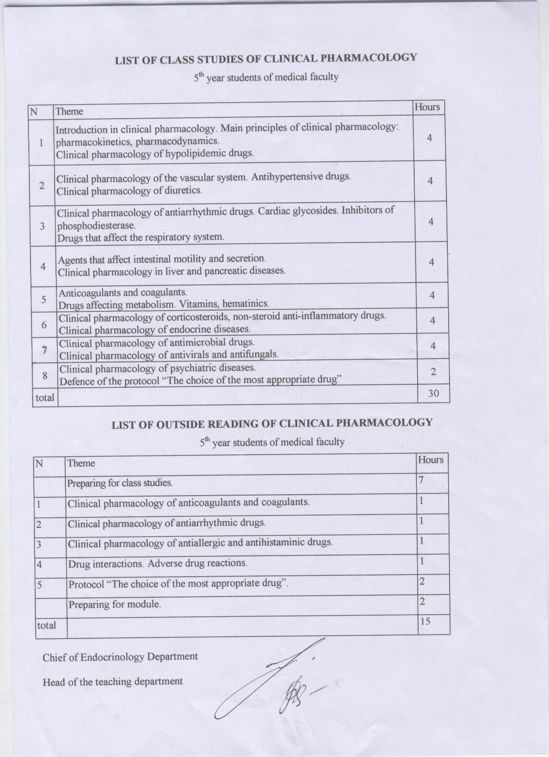

Thematic plan of Lectures
№ Theme of the lecture Lecturer
1 Asphyxia of newborns. Birth traumas. Prof. Dobryanskyy D.O.
2 Bacterial infections in newborns. Prof. Dobryanskyy D.O.
3 Hemolytic disease of newborns. Prof.Dobryanskyy D.O
4 Hemorrhagic diathesises in children. As. Prof. Gerasimov S.
5 Leukemia in children. As. Prof. Gerasimov S.
6 Diabetes mellitus in children. As. Prof. Gerasimov S.
Total: 12 hours

Thematic plan of Practical Classes
№ Theme Hours Credits
Module 2.
Neonatology
35 1,2
1 Asphyxia of newborns. Birth
traumas.
7 0,3
2 Hemolytic disease of newborns. Hemorrhagic
disease of newborns.
7 0,3
3 The peculiarities of premature newborns adaptation.
Medical care for premature newborns. Respiratory
distress-syndrome in newborns.
7 0,2
4 Bacterial infections in newborns. Neonatal
pneumonia.
7 0,2
5 TORCH-infections in children. 7 0,2
Module 3.
Blood and endocrine system diseases in children.
35 1,2
6 Anemias in children. 7 0,3
7 Leukemia and lymphomas in children. 7 0,3
8 Hemorrhagic vasculitis (Schonlein-Henoch disease).
Trombopenias and trombopathias in children.
Hemophilia in children.
7 0,2
9 Thyroid and parathyroid glands disorders.
Hypophisis and hypotalamus dysfunctions.
Reproductive system diseases in children.
7 0,2
10 Diabetes mellitus in children. Emergency situations
in diabetes mellitus in children.
7 0,2
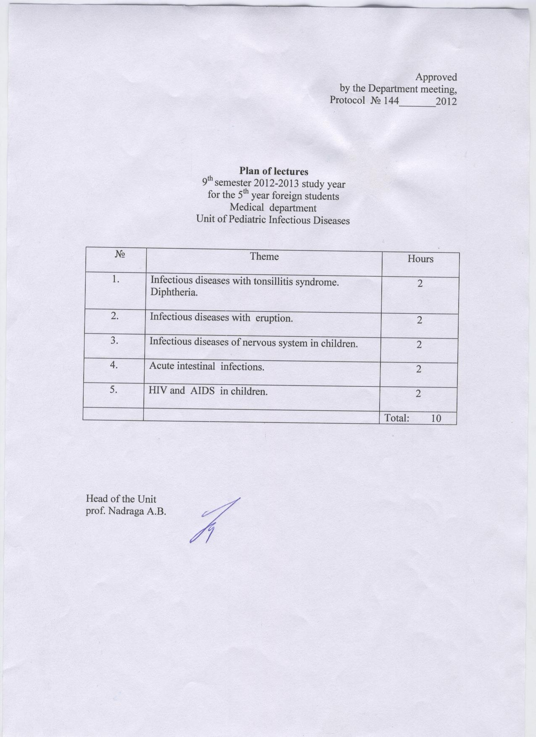
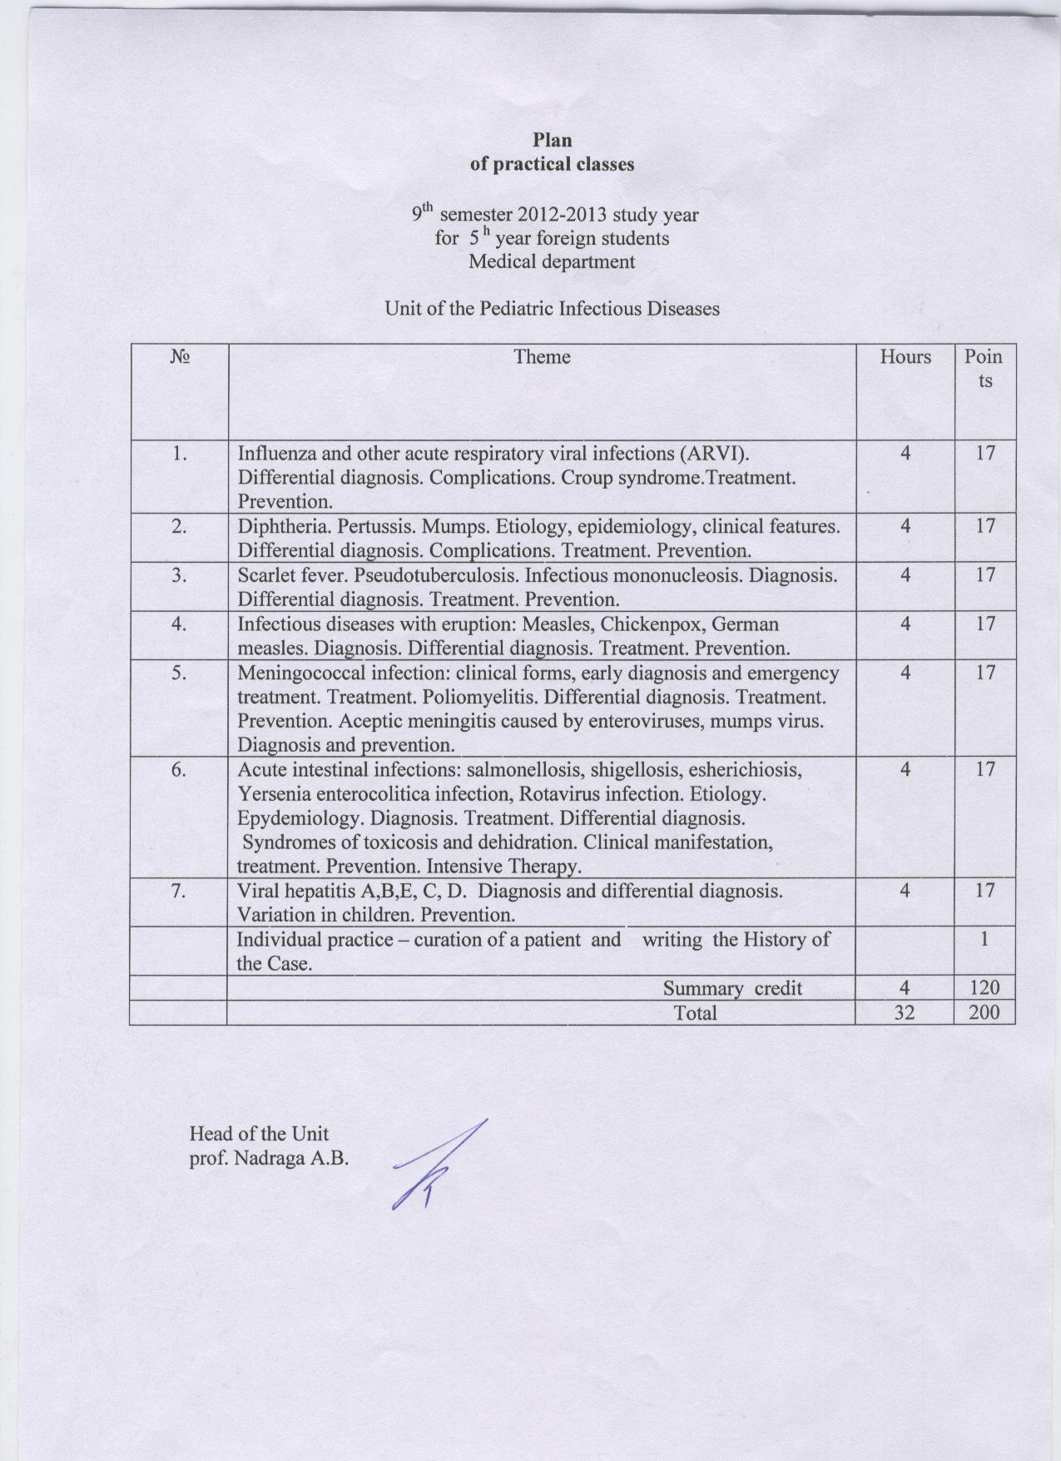
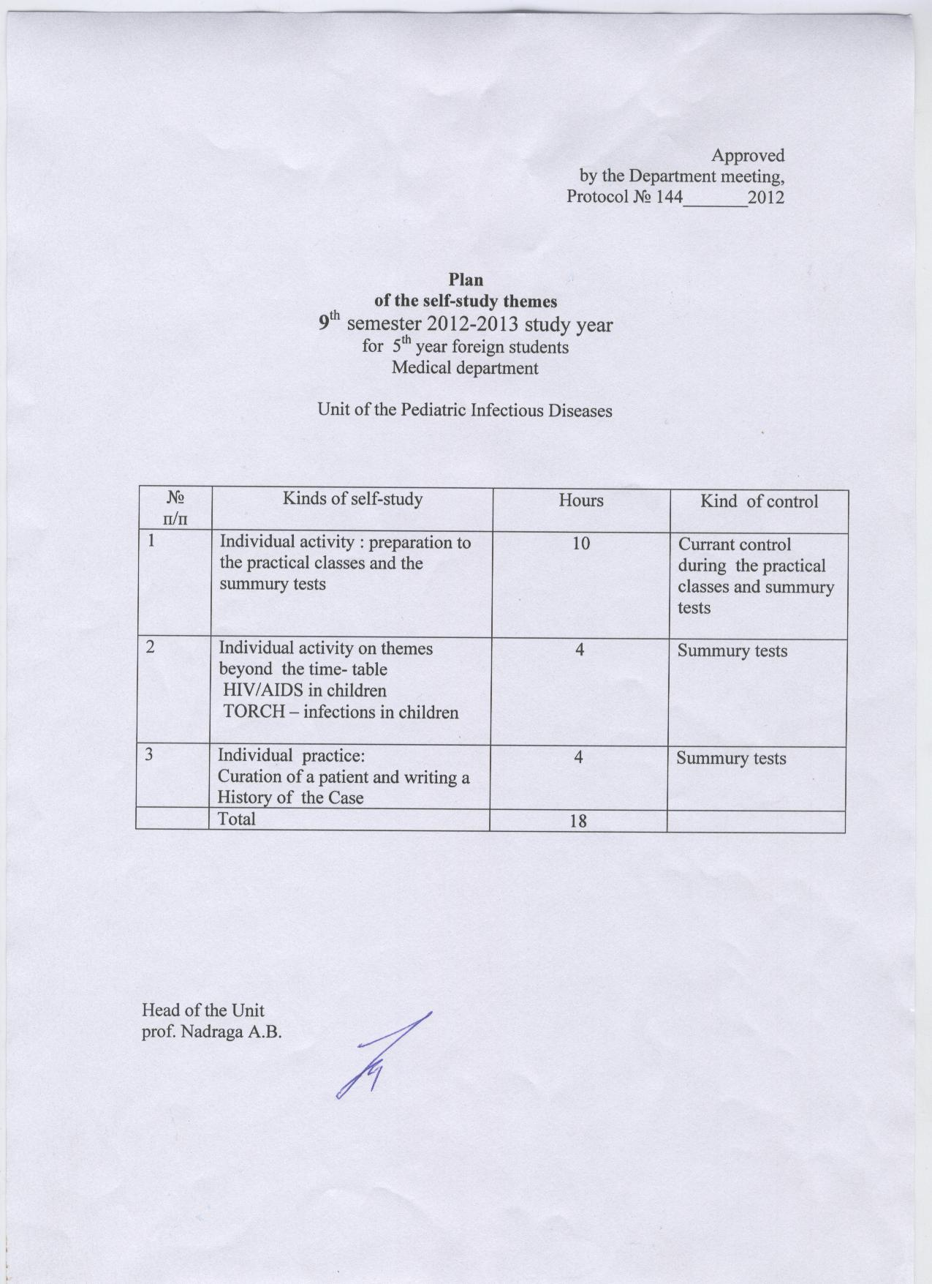

The themes of lectures for obstetrics for English-medium students V year medical faculty on IX term 2012-2013 academic year.

Credit 2. Pathologic pregnancy, labor and puerperium.

№ | TOPIC | HOURS
1. | Early gestoses. Hypertension in pregnancy. Preeclampsia and eclampsia. | 2
2. | Noncarrying of pregnancy. | 2
3. | Obstetric bleeding in early pregnancy. Ectopic pregnancy. Obstetric bleeding in late pregnancy. Postpartum bleeding and abnormalities of the third stage. Intensive care and resuscitation. | 2
4. | Obstetric operation. Traumatic lesions. | 2
5. | Postpartum septic diseases. | 2
 | Всього | 10

The themes of lectures for gynecology for English-medium students V year medical faculty on IX term 2012-2013 academic year.

Credit 3. Diseases of the female reproductive system. Family planning.

№ | TOPIC | HOURS
1. | Menstrual abnormalities. Neuroendocrine syndromes in gynecology. | 2
2. | Benign tumors of the female genital organs. | 2
3. | Background and precancerous diseases of the female genital organs. Malignant tumors female genital organs. | 2
4. | Inflammatory diseases of the female reproductive organs. | 2
5. | Infertile marriage. Family planning. | 2
 | Всього | 10

Teaching Plans “Neurosurgery” for Medical Students of 5th Year, Medical Faculty
Lviv National Medical University named after Danylo Galitsky
Department of Neurology&Neurosurgery

Lectures. (10 hours)
- Brain injury: classification, periods. Brain concussion. Brain contusion. Skull fractures. Intracranial traumatic mass lesions. Brain herniations. (2 hours)
- Injury to the spine and spinal cord. (2 hours)
- Brain tumors. Hydrocephalus. (2 hours)
- Spine and spinal cord tumors. Degenerative spine disease. (2 hours)
- Vascular CNS diseases, ischemic and hemorrhagic stroke. (2 hours)

Practicals.(20 hours)
- Brain injury: classification, periods. Brain concussion. Brain contusion of mild and moderate degree. Skull fractures. (2 hours)
- Severe brain contusion. Diffuse axonal injury. Intracranial traumatic mass lesions: hematomas of different localization, displaced skull fractures. Brain herniations. (2 hours)
- Injury to the spine and spinal cord: classification, types of vertebral fractures. (2 hours)
- Neurooncology. Tumors of the brain. Histological types, methods of treatment. Hydrocephalus. (2 hours)
- Spinal tumors. Histological types, methods of treatment.(2 hours)
- Degenerative diseases of the spine, cervical, lumbar discs. (2 hours)
- Vascular diseases of CNS. Ischemic stroke. (2 hours)
- Vascular diseases of CNS. Hemorrhagic stroke. (2 hours)
- Functional and reconstructive neurosurgery. Pain therapy and surgery. (2 hours)
- Module control (2 hours)

Self-educational work (15 hours)
- History of neurosurgery, stages of scientific development. Diagnostic methods in neurosurgery. (5 hours)
- Brain and spinal cord abscesses. Spinal extradural abscess. (5 hours)
- Congenitive pathology of CNS. Craniosynostosis, hydrocephalus, cranial and spinal neural hernias. (5 hours)

